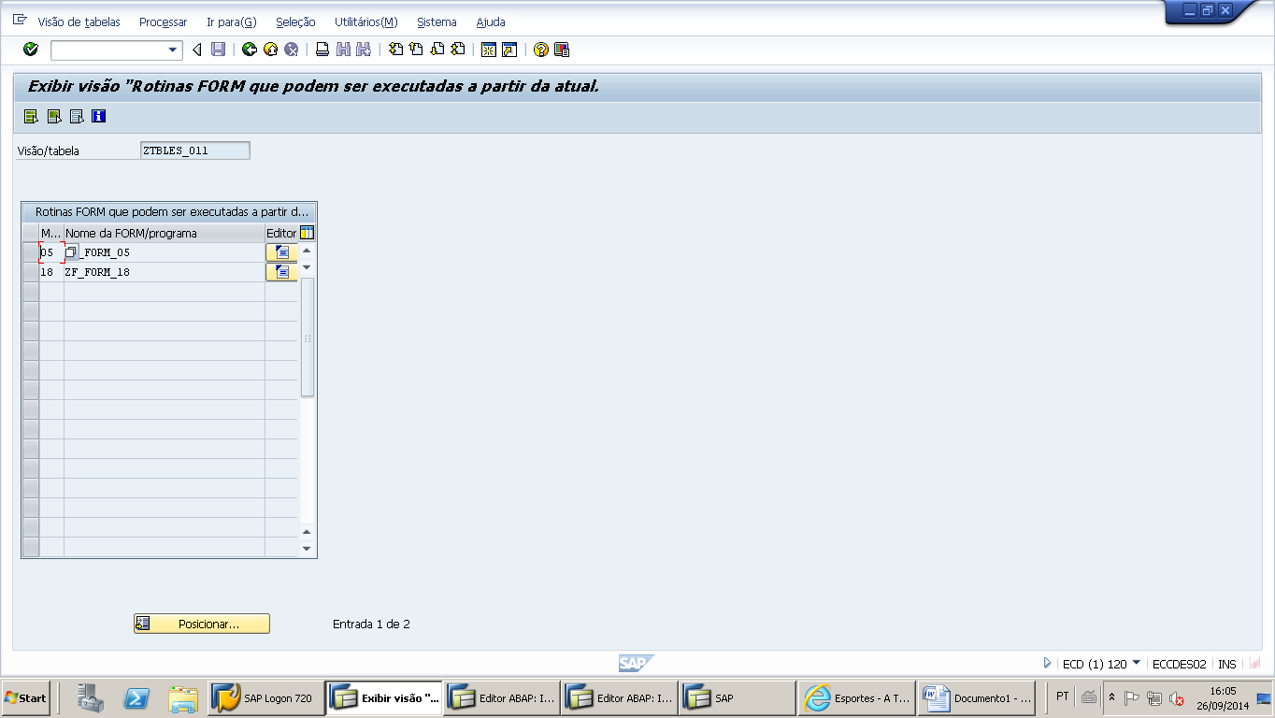

*--------------------------------------------------------------------*

*** LZRLES_008TOP

*--------------------------------------------------------------------*

*--------------------------------------------------------------------  
* Constantes  
*--------------------------------------------------------------------  
CONSTANTS:  
 cc_uname       TYPE field  
               VALUE 'UNAME',  
 cc_udate       TYPE field  
               VALUE 'DATUM',  
 cc_uzeit       TYPE field  
               VALUE 'UZEIT'  
               .  
*--------------------------------------------------------------------  
* Variáveis  
*--------------------------------------------------------------------  
DATA:  
 gw_name       TYPE field,  
 gw_value      TYPE value  
 .  
*--------------------------------------------------------------------  
* Ponteiros  
*--------------------------------------------------------------------  
FIELD-SYMBOLS:  
 <fs_wa>       TYPE any,  
 <fs_field>    TYPE any  
 .

********************************************************************************************************************************************

*--------------------------------------------------------------------*  
***INCLUDE LZRLES_008F01.  
*--------------------------------------------------------------------*  
  
*&---------------------------------------------------------------------*  
*&      Form  ZF_FORM_05  
*&---------------------------------------------------------------------*  
*       A cada novo registro inserido na tabela  
*----------------------------------------------------------------------*  
FORM zf_form_05.  
  
*--chamada da rotina passando parâmetros  
  PERFORM zf_log_new USING x_header.  
  
ENDFORM.                    "ZF_FORM_05  
  
*&---------------------------------------------------------------------*  
*&      Form  ZF_FORM_18  
*&---------------------------------------------------------------------*  
*       Ao modificar algum registro da tabela  
*----------------------------------------------------------------------*  
FORM zf_form_18.  
  
*--chamada da rotina passando parâmetros  
  PERFORM zf_log_modify TABLES extract  
                               total  
                         USING x_header.  
  
ENDFORM.                    "ZF_FORM_18

*&---------------------------------------------------------------------*  
*&      Form  zf_log_modify  
*&---------------------------------------------------------------------*  
*       Ao modificar algum registro da tabela  
*----------------------------------------------------------------------*  
FORM zf_log_modify  TABLES extract  TYPE STANDARD TABLE  
                           total    TYPE STANDARD TABLE  
                     USING x_header TYPE vimdesc.  
*--declaração local  
  DATA:  
   o_dy_table TYPE REF TO data,  
   o_dy_line  TYPE REF TO data,  
  
   lw_fc      TYPE lvc_t_fcat,  
   lc_change  TYPE c  
  .  
  
  FIELD-SYMBOLS:  
   <fs_table> TYPE STANDARD TABLE,  
   <fs_struc> TYPE any,  
  
   <fs_field>  TYPE any.  
  
  UNASSIGN: <fs_table>, <fs_struc>  
  .  
  IF lw_fc[] IS INITIAL.  
*--cria a dinamicamente a estrutura da work area.  
    PERFORM zf_monta_fieldcat TABLES lw_fc  
                               USING x_header-viewname.  
  
*--cria a dinamicamente a estrutura da work area.  
    PERFORM zf_monta_fieldcat TABLES lw_fc  
                               USING 'VIMFLAGTAB'.  
  ENDIF.  
  
  CALL METHOD cl_alv_table_create=>create_dynamic_table  
    EXPORTING  
      it_fieldcatalog = lw_fc  
    IMPORTING  
      ep_table        = o_dy_table.  
  
  ASSIGN o_dy_table->* TO  <fs_table>.  
  
  IF  <fs_table> IS ASSIGNED.  
    CREATE DATA o_dy_line LIKE LINE OF <fs_table>.  
    ASSIGN o_dy_line->* TO <fs_struc>.  
  
    IF <fs_struc> IS ASSIGNED.  
  
      LOOP AT extract INTO <fs_struc>.  
        UNASSIGN: <fs_field>.  
        ASSIGN COMPONENT 'ACTION' OF STRUCTURE <fs_struc> TO <fs_field> .  
  
        CHECK <fs_field> IS ASSIGNED.  
        CHECK <fs_field> = 'U'. "registro modificado  
  
        lc_change = abap_true.  
  
        UNASSIGN: <fs_field>.  
        ASSIGN COMPONENT cc_UNAME OF STRUCTURE <fs_struc> TO <fs_field> .  
        IF <fs_field> IS ASSIGNED.  
          <fs_field> = sy-uname.  
        ENDIF.  
  
        UNASSIGN: <fs_field>.  
        ASSIGN COMPONENT cc_UDATE OF STRUCTURE <fs_struc> TO <fs_field> .  
        IF <fs_field> IS ASSIGNED.  
          <fs_field> = sy-datum.  
        ENDIF.  
  
        UNASSIGN: <fs_field>.  
        ASSIGN COMPONENT cc_UZEIT OF STRUCTURE <fs_struc> TO <fs_field> .  
        IF <fs_field> IS ASSIGNED.  
          <fs_field> = sy-uzeit.  
        ENDIF.  
  
        MODIFY extract FROM <fs_struc>.  
      ENDLOOP.  
    ENDIF  
   .  
  ENDIF  
  .  
*--somente se algum registro foi modificado.  
  IF lc_change IS NOT INITIAL.  
    total[] = extract[].  
  ENDIF.  
ENDFORM.                    "zf_log_modify  
*&---------------------------------------------------------------------*  
*&      Form  ZF_LOG_NEW  
*&---------------------------------------------------------------------*  
*       A cada novo registro inserido na tabela  
*----------------------------------------------------------------------*  
FORM zf_log_new USING x_header TYPE vimdesc.  
  
  CLEAR: gw_name, gw_value.  
  UNASSIGN: <fs_field>, <fs_wa>  
  .  
  ASSIGN (x_header-viewname) TO <fs_wa>.  
  
  DO 3 TIMES.  
    CASE sy-index.  
      WHEN 1.  
        gw_name = cc_uname.  
        gw_value = sy-uname.  
      WHEN 2.  
        gw_name = cc_udate.  
        gw_value = sy-datum.  
      WHEN OTHERS.  
        gw_name = cc_uzeit.  
        gw_value = sy-uzeit.  
    ENDCASE.  
  
    ASSIGN COMPONENT gw_name OF STRUCTURE <fs_wa> TO <fs_field>.  
    IF sy-subrc = 0.  
      <fs_field> = gw_value.  
    ENDIF.  
  ENDDO.  
  
ENDFORM.                    "ZF_LOG_NEW  
*&---------------------------------------------------------------------*  
*&      Form  ZF_MONTA_FIELDCAT  
*&---------------------------------------------------------------------*  
FORM zf_monta_fieldcat  TABLES   t_fc STRUCTURE lvc_s_fcat  
                         USING   p_st TYPE any.  
*--objetos locais  
  DATA:  
    ls_fc        TYPE lvc_s_fcat,  
    lc_tabname   TYPE tabfield-tabname,  
  
    lw_dfies_tab TYPE TABLE OF dfies,  
    ls_dfies_tab LIKE LINE OF lw_dfies_tab  
    .  
  CLEAR: lc_tabname, lw_dfies_tab[].  
  
  lc_tabname = p_st.  
  CALL FUNCTION 'DDIF_FIELDINFO_GET'  
    EXPORTING  
      tabname        = lc_tabname  
      langu          = sy-langu  
      all_types      = 'X'  
    TABLES  
      dfies_tab      = lw_dfies_tab  
    EXCEPTIONS  
      not_found      = 1  
      internal_error = 2  
      OTHERS         = 3.  
  
  IF sy-subrc <> 0.  
    RETURN.  
  ENDIF.  
  
  LOOP AT lw_dfies_tab INTO ls_dfies_tab.  
    CLEAR  ls_fc.  
    ls_fc-fieldname = ls_dfies_tab-fieldname.  
    ls_fc-datatype  = ls_dfies_tab-datatype.  
    ls_fc-inttype   = ls_dfies_tab-inttype.  
    ls_fc-intlen    = ls_dfies_tab-leng.  
    ls_fc-decimals  = ls_dfies_tab-decimals.  
    APPEND ls_fc TO t_fc.  
  ENDLOOP.  
  
ENDFORM.                    " ZF_MONTA_FIELDCAT